**Branch :- Computer Sci. & Engg. Class :- III Year**

**Subject :- DBMS Sem :- V**

**Teacher Manual**

**PRACTICAL NO 1**

**AIM**: To Study a Database Modeling Tool.

**S/W REQUIRED:** Smartdraw/ Lucidchart

Study of Data Modeling Tools

* Take a description of the enterprise, create its corresponding ER Diagram and build a database model using any modeling tool. The following basic features of the modeling should be covered while building the model: Logical / Physical Modeling
* Adding an entity / its attributes , relationships (all kinds of relationships viz., parent-child, foreign key references, one to many, many to many etc)
* Forward / reverse engineering ,Details of forward engineering / schema generation
* Steps to generate the schema

## What is an Entity Relationship Diagram (ERD)?

An entity relationship diagram (ERD) shows the relationships of entity sets stored in a database. An entity in this context is an object, a component of data. An entity set is a collection of similar entities. These entities can have attributes that define its properties.

By defining the entities, their attributes, and showing the relationships between them, an ER diagram illustrates the logical structure of databases.

ER diagrams are used to sketch out the design of a database.

## **The History of Entity Relationship Diagrams**

Peter Chen developed ERDs in 1976. Since then Charles Bachman and James Martin have added some slight refinements to the basic ERD principles.

## **Common Entity Relationship Diagram Symbols**

An ER diagram is a means of visualizing how the information a system produces is related. There are five main components of an ERD:

**Entities**, which are represented by rectangles. An entity is an object or concept about which you want to store information.

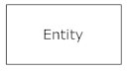

A weak entity is an entity that must defined by a foreign key relationship with another entity as it cannot be uniquely identified by its own attributes alone.

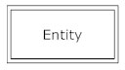

**Actions**, which are represented by diamond shapes, show how two entities share information in the database

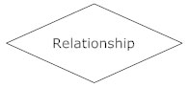

In some cases, entities can be self-linked. For example, employees can supervise other employees.

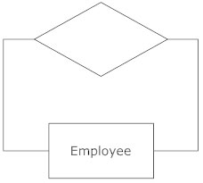

**Attributes**, which are represented by ovals. A key attribute is the unique, distinguishing characteristic of the entity. For example, an employee's social security number might be the employee's key attribute.

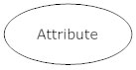

A multivalued attribute can have more than one value. For example, an employee entity can have multiple skill values.

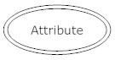

A derived attribute is based on another attribute. For example, an employee's monthly salary is based on the employee's annual salary.

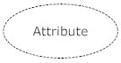

* **Connecting lines**, solid lines that connect attributes to show the relationships of entities in the diagram.
* **Cardinality** specifies how many instances of an entity relate to one instance of another entity. Ordinality is also closely linked to cardinality. While cardinality specifies the occurrences of a relationship, ordinality describes the relationship as either mandatory or optional. In other words, cardinality specifies the maximum number of relationships and ordinality specifies the absolute minimum number of relationships.

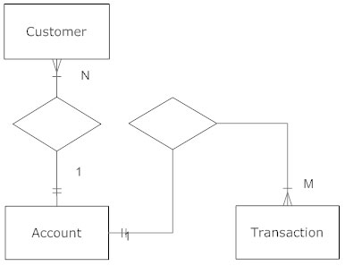

There are many notation styles that express cardinality.  
**Information Engineering Style**

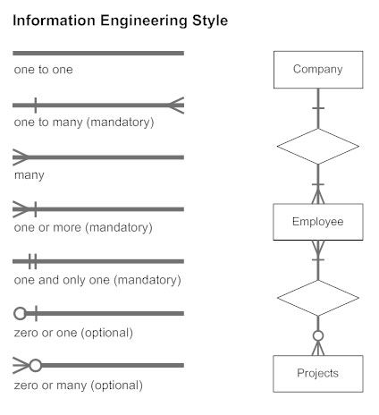

Here are some best practice tips for constructing an ERD:

* **Identify the entities.** The first step in making an ERD is to identify all of the entities you will use. An entity is nothing more than a rectangle with a description of something that your system stores information about. This could be a customer, a manager, an invoice, a schedule, etc. Draw a rectangle for each entity you can think of on your page. Keep them spaced out a bit.  
  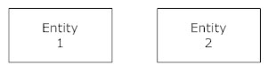
* **Identify relationships.** Look at two entities, are they related? If so draw a solid line connecting the two entities.
* **Describe the relationship.** How are the entities related? Draw an action diamond between the two entities on the line you just added. In the diamond write a brief description of how they are related.
* **Add attributes.** Any key attributes of entities should be added using oval-shaped symbols.
* **Complete the diagram.** Continue to connect the entities with lines, and adding diamonds to describe each relationship until all relationships have been described. Each of your entities may not have any relationships, some may have multiple relationships. That is okay

## Tips for Effective ER Diagrams

1. Make sure that each entity only appears once per diagram.
2. Name every entity, relationship, and attribute on your diagram.
3. Examine relationships between entities closely. Are they necessary? Are there any relationships missing? Eliminate any redundant relationships. Don't connect relationships to each other.
4. Use colors to highlight important portions of your diagram.

**Modeling Tools of ERD**

1. **Smartdraw :** SmartDraw includes templates quick-start  for over 70 different diagram types from flowcharts to floor plans. Powerful automatic formatting means perfect layouts in minutes. It's the right fit whether you're working on your own. Build diagrams like flow charts, ERD, and class diagrams from data with built-in extensions or enhance any diagram with shape data and generate manifests.

### Lucidchart : Visualize relationships with our entity relationship modeling tool

### Entity relationship diagrams (ERDs) help you understand relationships between entities within a system, such as customers, products, or order IDs. An entity relationship diagram tool like Lucidchart helps you conceptualize your database design before you build it, including the overall structure and the ways different types of data interact, if at all. So, if you’re designing, patching, or debugging relational databases for software engineering, business information systems, or another industry, create ER diagrams online to better visualize your schemas, while spotting and correcting flaws early on.

1. **Draw.io : rathi mam add details**

**Output: ERD Drawing of project using any of above tools.**

**CONCLUSION:** ThusERD tools studied and draw E-R Diagram using tools(tools/software name).